**Related works :**

The functional Components in the system are sensors and motor pump. Arduino with Arduino IDE software. Moisture sensor is used to moisture level of soil, motor is used to supply water. Ranges of sensor is set according requirement of plants with these setting micro controller works, all sensor are connected to input pins of controller, pump motor is connected to output pin, so that when soil moisture falls below threshold value system triggers motor automatically till threshold level is reached and reported to user using mobile application

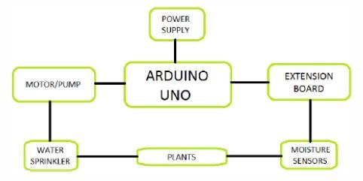

***Fig:Block diagram of existing work***

## *Aspects of the system*

*Measuring Mositure content*

Soil moistures placed in field performs this action . they are connected to arduino board and sensors sends sensed data signal to board.

On Receiving logical high data signal arduino checks with threshold and notify whether to turn on motor or not. Arduino is used in combination with relay network to control motor pumps and motor is driven by external 9 volt battery.

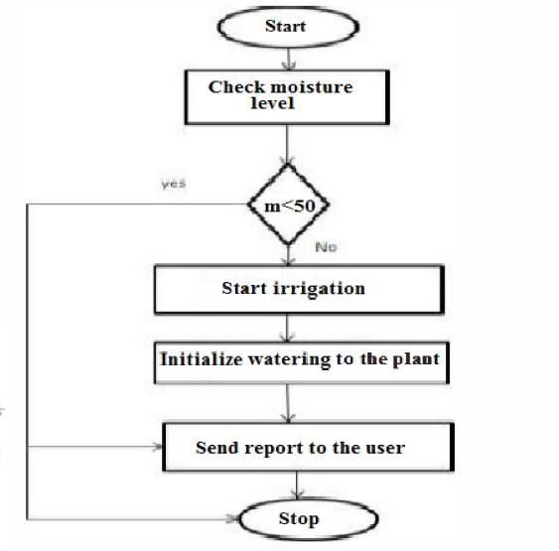

***Fig:Flow chart of the system***

***Components used for Implementation of the system***

## Arduino Board (UNO)

Arduino is micro-controller based on Atmega328, having 14 digital In/Out pins of which 6 are for PWM output, 6 are for analog input. Operates at 16 MHz, with a USB, Power jack, rst button

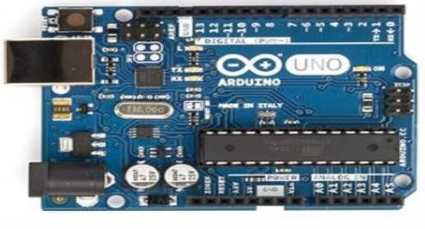

***Fig:Arduino board***

## Moisture Sensor

Soil Moisture Sensor detects the moisture content of soil, it consists of a plurality of soil moisture sensors.

Technology used is Frequency domain Sensor i.e., capacitive sensor, moisture meter characteristic of the use of water in the neutron moderator

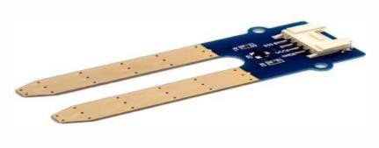

### Fig:Temperature Sensor Water Pump

It performs specfic task of artificial watering to plants,

Here it is controlled by microcontroller electronically, it can be on 1 triggered by sending signal and can be turned off as needed. Here we used H-bridge connected small pump.

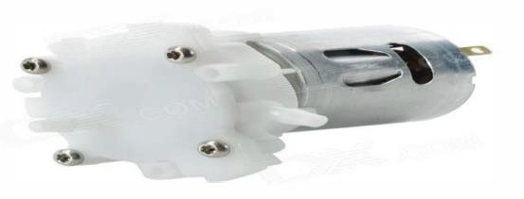

***Fig:Water Pump***

## Relay Module

Relay is an electrical switch. It uses solenoid mechanism that is operated mechanically

Relay system provides provision for operating motor by microcontroller because, microcontoller cannot directly control motor, because power supplied by cotroller is not suuficient to drive motor

## Arduino IDE Tool

Arduino IDE tool (software) is a open source environment where we can write a code and upload it on to UNO board . it runs on

windows Mac os and Linux Os

.

**Proposed Work :**

Proposed work have many advantages over the existing

* Used Raspberry Pi , which can handle many tasks , whereas arduino can perform single task at once.
* Here, we use an ANDROID application for not only monitoring the readings from sensors, but also we can give threshold limit for automating motor based on moisture level in soil
* 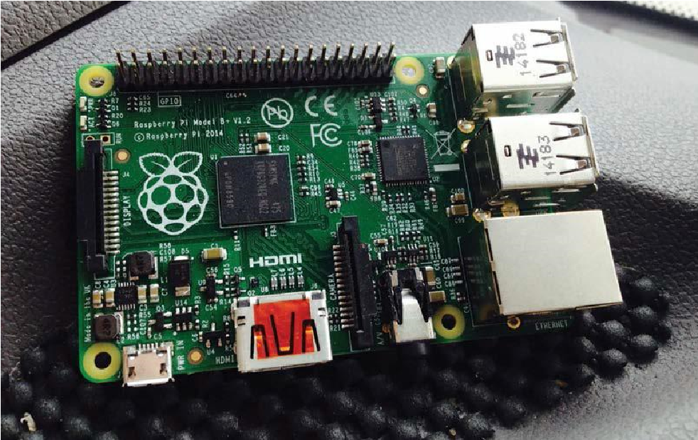The proposed architecture is given in the figure

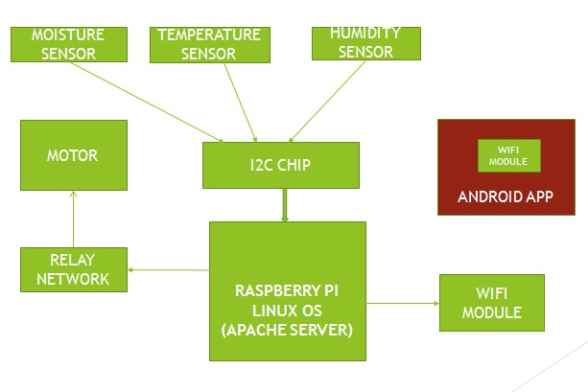

### Fig:Block diagram of Proposed Work Components used for Implementing the System Raspberry Pi

It is single board device developed by UK- Raspberry Pi foundation, for promoting teachings on basics of computer science and original model became more popular than anticipated mainly used in robotics and can be connected to keyboard, mouse ect.,

***Fig:Raspberry Pi***

## USB ports

As raspberry Pi can perform similar actions that of computer, It have a provision to interface with keyboar, mouse by using USB port, raspberry has 4USB ports. Since the ports don’t provide much power we have to find a device that comes with an external power supply

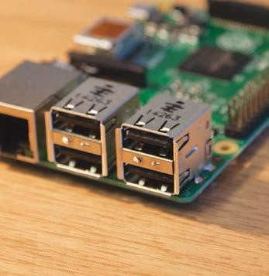

***Fig:USB port***

## Ethernet port

The most traditional way for connecting internet to device by using ethernet cable, raspberry pi have ethernet port for connecting internet to Pi board, and easier method to setup than wi-fi and provide faster internet than alternate ways,

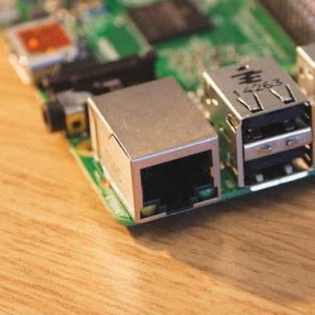

***Fig:Ethernet Port***

## GPIO header

GPIO stands for General Purpose Input Output port, used for set up of connection for various functions, mainly to connect Raspberry Pi to an

Electronic circuit using progarmming

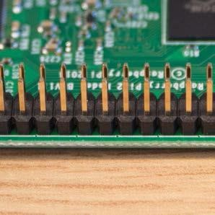

***Fig:GPIO pins***

## MicroSD card slot

A micro SD card is used hard drive for Pi, SD card will have Operating System loaded into it. .A computer doesn’t have provision for connecting SD card directly to it.

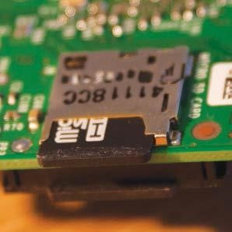

***Fig:Micro SD card Slot***

### Power

Power supply to Raspberry Pi is given through

Power that is similar to Smart Phone charger pin, Power supply can be given from a Charger ie.

Mobile charger, or can be given from PC

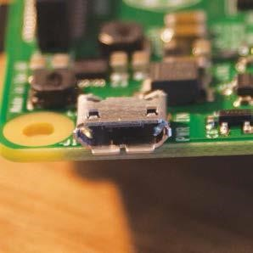

***Fig:3.8:Power Pin***

## HDMI port

HDMI port is used fro connectng Raspberry Pi with TV and Monitor to see on required Screen

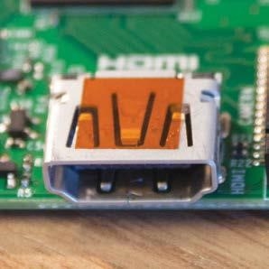

***Fig*:HDMI Port**

## Operating system (LINUX OS)

Embedded sytem, a combination of hardware and software.Hardware is RASPBERRY PI- It is a micro computer that performs all tasks done by computer like storage , communicating etc,

* Software is LINUX OS- OS is defined as code that runs hardware kernel bit set. It is an interface between user and the architecture.
* LINUX OS is open source operating system and is freely distributed cross-platform

## Temperature and Humidity sensor

*Temperaature and humidity sensor used is DHT11. It has a complex feature with a calibrated digital signal as output. This sensoe has digital acquisition technique and sensing technology which makes it highly reliable and long term stable.*

*This has a resistive type humidity measuring component connected to a micro controller offering excellent, quality, fast response, antiinterference ability and cost effectiveness*